*Translated from Romanian into English language*



**THEMATIC REPORT**

**MONITORING AND IMPLEMENTATION OF RECOMMENDATIONS**

**OF THE CHILDREN'S OMBUDSMAN DURING THE MANDATE 2016-2020**

**CHISINAU, 2020**

**AUTHOR: Elena DRAGHICI**

in collaboration with the employees of the People's Advocate Office,

Children's Rights Directorate,

Tamara TENTIUC, Head of Directorate,

Liliana DUBENCO, Senior Consultant



**THIS REPORT WAS DRAFTED WITH THE FINANCIAL SUPPORT OF UNICEF (MOLDOVA).**

**ABBREVIATIONS LIST**

PACR- People's Advocate for Children's Rights;

PA- People's Advocate;

PAO- People’s Advocate Office

UN - United Nations

UNICEF - United Nations International Children's Emergency Fund

**CONTENTS:**

**Context** ………………………………………………………………………………………4-7

1. The People's Advocate Institution for Children’s Rights …………………………… 8-9
2. The recommendations of the Children's Ombudsman ………………………...……. 9-13
3. The legal mechanisms for monitoring the implementation way of recommendations

within the People's Advocate Office ………………………………..…………..….13-17

1. The international practice on the implementation of the Ombudsman's

Recommendations ……………………………………………………………….….17-19

**Conclusions/Recommendations** …………………………………………………………..20-21

ANNEXES ………………………………………………………………………………… 22-26

**CONTEXT**

*"Children are the world's most valuable resource and its best hope for the future."*

*John Fitzgerald Kennedy[1]*

The children are the future of society. For these reasons, special attention has always been paid to aspects that ensure the well-being and harmonious development of children. Over time the phenomenon of child protection has achieved the formulation of the fundamental rights and freedoms of the child.

The essential instrument in the promotion of children's rights is the UN Convention on the Rights of the Child, ratified by the Republic of Moldova by Parliament Decision No. 408-XII of 12.12.1990, effective since 25.02.1993. The red thread of this Convention is the approach to any problem and the defence of the rights of the child through the prism of 4 general principles: non-discrimination[2], the right to survival and development[3], the best interests of the child[4] and the right to express freely his/her opinion according to age and maturity[5].

The principles mentioned above require the legal subjects to leave aside the template analysis of the problems where children are concerned and to assess each individual case identifying optimal solutions to ensure the well-being and harmonious development of each child based on their individual characteristics.

The future of a society depends on the level of ensuring the harmonious development of today's child, which implies not only ensuring economic rights, but also cultivating moral and social values, which will then be reflected in the decisions of tomorrow's adults. For these reasons, the approach to cases involving children, irrespective of their legal status, is of crucial importance both for today's child and for tomorrow's society.

With the establishment of the institution of the Children's Ombudsman in the Republic of Moldova, the segment of child protection became more mediatized, and the problems faced by children of different ages were referred, under the Law no.52/2014 on the People’s Advocate (Ombudsman), to the relevant institutions for resolution and prevention of similar cases.

The theme of the report "Monitoring and implementation of recommendations of the Children's Ombudsman during the mandate 2016-2020" was conditioned by the need of assessment:

* the level of implementation of the Children's Ombudsman's feedbacks, in particular of the recommendations;
* the types of recommendations made by the Children's Ombudsman;
* the causes of non-implementation of some recommendations; and
* the impediments that usually arise when monitoring the implementation of the Ombudsman's recommendations.

Since children's rights cover aspects of all social and economic fields, the mechanism for defending and promoting them involves cooperation between public authorities. The practice has shown that the final result of the actions taken depends to a large extent on the quality of the inter-sectoral cooperation and the cooperation of the public authorities with the Children's Advocate. This will be assessed during 2016-2020 and reflected in this report.

**STUDY METHODOLOGY**

A complex methodology was used in the process of drafting the report, which involved the use of the comparative method, interviews and analysis of existing legal norms.

In order to obtain the most accurate information possible:

* the feedbacks of the People's Advocate for Children's Rights (hereafter PACR) were analysed, in particular the recommendations and
* the survey of the public authorities with which the PACR has worked more often.

**Overview**: The report aims to carry out, in the light of the mandate and powers of the PACR, an assessment of the degree of implementation/observance of the recommendations, issued by the PACR to the authorities, drafted and based, in the process of monitoring the observance of the rights and freedoms of the child guaranteed by the UN Convention on the Rights of the Child, during the mandate years 2016-2020.

The basic **objectives** in the research process are:

1. Assessment of the degree of implementation/observance of the recommendations, issued by the PACR to the authorities, drafted in the light of the UN Convention on the Rights of the Child, during the mandate years 2016-2020:

* Analysis of the system of monitoring and evaluation of the level of implementation of the recommendations of the People's Advocate for Children’s Rights within the People' s Advocate Office;

1. Problems/barriers faced by the PAO in the process of monitoring the level of implementation of the PACR recommendations;
2. Problems/barriers faced by public authorities in the process of implementing the PACR recommendations.

Basic **principles** of the process of assessing the degree of implementation/observance of the recommendations issued by the PACR to the authorities are:

1. cooperation and participation:
2. independence, objectivity and impartiality;
3. accountability;
4. transparency.

**The aim of the research**: to identify barriers and shortcomings in the process of monitoring and carrying out/implementing the recommendations of the Children's Ombudsman.

**The target group** that is to be analysed: Public authorities with which the PACR and PAO interacted during 2016-2020.

**The main fields covered by the assessment**:

1. *Analysis of the national legal and institutional framework* in the field of monitoring and implementation of the recommendations of the Children's Ombudsman.

This section will examine whether the process of monitoring the recommendations of the Children's Ombudsman is regulated by the legislation in force.

1. *Analysis of the recommendations of the Children's Ombudsman during 2016-2020*.

This analysis will identify the reasons for non-implementation or partial implementation of the recommendations of the Children's Ombudsman (e.g. political will, lack of time, lack of financial means, etc.).

1. *Analysis of the Children Ombudsman's relationship with state authorities in the light of the Belgrade Principles.*

The examination of the answers received from the authorities following the recommendations submitted will allow the analysis of the existing relationship between them and the Ombudsman institution, in particular with the PACR. In addition, in order to strengthen the expert's conclusions, a survey will be sent to the authorities to ascertain their perception of the recommendations they receive from the Children's Ombudsman.

1. *Analysis of the legal levers for monitoring the implementation of the PACR recommendations.*

This section will identify the existing mechanism within the PAO for monitoring the observance/implementation of the Children's Ombudsman's recommendations.

**The technique for assessing** the degree of implementation/observance of the recommendations issued by the PACR to the authorities involves:

* conducting desk research (analysis of legislation and existing mechanisms in the field concerned);
* examining existing documentation;
* analysing the information obtained;
* the linking of the information obtained to national and international regulations to which the Republic of Moldova is part of;

1. **THE PEOPLE'S ADVOCATE FOR CHILDREN’S RIGHTS**

The tendency of democratic society to ensure the observance of human rights has conditioned the creation of independent national institutions to protect and monitor the enforcement of fundamental human rights and freedoms.

The Principles relating to the status of national institutions for the promotion and protection of human rights (the Paris Principles), adopted by United Nations (UN) General Assembly Resolution No 48/134 of December 20, 1993, being among the basic instruments for the creation of national institutions for the promotion and protection of human rights, conditioned the creation of such an entity in the Republic of Moldova in 1997.

The need to establish an institution to deal exclusively with the issue of children's rights, a Children's Advocate (Ombudsman), was set out in the Report on the observance of human rights in the Republic of Moldova in 2007.[6]

Subsequently, in order to ensure the observance of the children's rights, on March 20, 2008, for the first time in the Republic of Moldova, the institution of the Parliamentary Advocate for the Protection of the Children's Rights was established.

The role of the Children's Ombudsman, by virtue of the powers conferred by the legislation[7] in force, is of primary importance in the process of monitoring the observance of the fundamental rights and freedoms of the child.

In the light of art. 1 (3) of the Law on the People's Advocate (Ombudsman), the People’s Advocate for Children’s Rights’ protection performs her duties to ensure the protection of child rights and freedoms, at the national level, by the central and local public authorities, by the decision making officials at all levels of the provisions of the UN Conventions for the Protection of the Rights of the Child.

The basic principles, which guide the Children's Ombudsman in his work, are: legality, equality, impartiality, transparency, social equity, democracy, humanism and to be guided by her conscience.

Among the basic mechanisms assigned to the Children's Ombudsman by the legislation[8] in force are: monitoring the observance of children's rights at national level, improving legislation on children's rights, international cooperation in this field, promoting the fundamental rights and freedoms of the child and of their defence mechanisms.

The PACR, during 2016 - first half of 2020, reacted to violations and attempted violations of children's rights by sending to the authorities’ opinions with recommendations, opinions on draft regulations and proposals to amend legislation, submission of complaints and Amicus Curae at the Constitutional Court.

Usually the most frequent feedbacks of the Children's Ombudsman are the opinions with recommendations on the measures to be taken by the authorities in her activity, with a view to the immediate restoration of rights, as well as the prevention of similar cases. Given the fact that violations of children's rights have been identified, the PACR submits opinions with recommendations, the level of monitoring and implementation of which is to be analysed.

1. **RECOMMENDATIONS OF THE CHILDREN'S OMBUDSMAN**

*"The Ombudsman shall have the power to address individual recommendations to any bodies or institutions within the competence of the Institution. The Ombudsman shall have the legally enforceable right to demand that officials and authorities respond within a reasonable time set by the Ombudsman."*

Principles on the Protection and Promotion of the Ombudsman Institution (The Venice Principles), adopted by the Venice Commission at its 118th Plenary Session (March 15-16, 2019)

According to art.24 (1) of the Law no.52/2014 on the People’s Advocate (Ombudsman): ”In the situations when are found violations of the petitioner’s rights or freedoms, the People’s Advocate presents to the authority or responsible official whose decisions, actions or inactions, in his/her opinion violate the human rights and freedoms, a notice covering the recommendations on measures to be undertaken for the immediate restoration of the petitioner’s rights.”

The moment of intervention of the Children's Ombudsman with recommendations occurs with the detection of violations or attempted violations of children's rights brought to the attention of the dignitary through: requests from the population of the Republic of Moldova, approaches of public authorities, visits in the territory (public authorities of educational, social, psychosocial, health, re-education and social reintegration etc.), hotline, media.

It should be noted that, as a rule, an application is accepted for examination by the Children's Ombudsman in cases where the public authorities do not properly exercise their functional powers in accordance with the law. Respectively, in order to redress the situation the official intervenes with a reactionary act.

According to the data presented by PAO, during 2016 - first half of 2020, out of the total number of opinions with recommendations about 62% of opinions were for reinstatement of rights, 18% are opinions with recommendations for prevention of violations, 9% are opinions with recommendations for training of public authority staff and 5% of opinions had as recommendations, improvement of the legal framework. These data are reflected in Figure no. 1

**Figure No. 1**

**Types of recommendations**

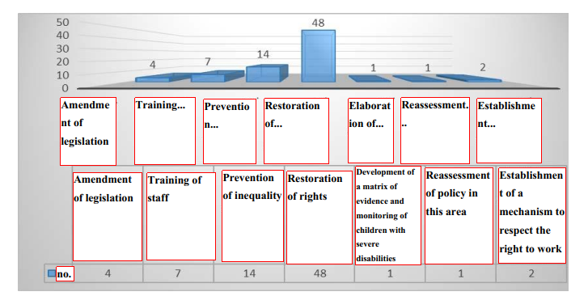

Source: Opinions with recommendations of the Children's Ombudsman in during 2016 - first half of 2020 provided by PAO

It should be noted that in some opinions of the PACR there are also recommendations to amend the institutional legal framework, because the violations detected were conditioned by the existence of either an institutional framework outdated by social realities or by the existence of legislative gaps. And in order to solve the case and prevent similar situations, in addition to administrative actions, the Children's Ombudsman considered it necessary to improve the legal framework, in most cases, the institutional framework as well.

The statistical data show that out of the total number of complaints examined by the Children's Ombudsman, more often abuse and neglect in educational institutions, domestic violence, violence in educational institutions, violation of the right to social protection, violence between children were invoked. These data point to existing trends and areas where intervention is needed to prevent similar situations. More detailed information is reflected in Table 1.

**Table no. 1**

**Classification of opinions by violated rights**

|  |  |
| --- | --- |
| **No. of opinions** | **Violated right** |
| 3 | social protection of children with disabilities |
| 11 | abuse and negligence in educational institutions |
| 1 | sexual abuse between minors |
| 4 | friendly environment |
| 4 | education |
| 3 | protection against degrading treatment |
| 3 | physical violence |
| 2 | protection of orphaned children |
| 5 | social protection |
| 1 | protection of children in situations of risk |
| 1 | right to an opinion |
| 1 | right to religion |
| 2 | protection and support of the family |
| 1 | escorting minor prisoners |
| 2 | health |
| 4 | violence between children |
| 1 | state-guaranteed legal aid |
| 5 | violence in educational institutions |
| 4 | work under legal conditions |
| 8 | protection against domestic violence |
| 2 | enforcement of court decisions |
| 2 | right to communicate with parents and grandparents |
| 1 | right to defence |

Source: Opinions with recommendations of the Children's Ombudsman during 2016 - first half of 2020 provided by the PAO

Once an opinion with recommendations has been sent, the public authority concerned is entitled to inform the Children's Ombudsman of the results of the examination and the action taken.

Pursuant to art.24 (3) of the Law on the People's Advocate (Ombudsman): ”The authority or responsible official who did receive the notice is obliged to review it in a 30 day term and to communicate in writing to the People’s Advocate on the measures undertaken in order to remedy the situation”.

According to art.24 (4) of the same Law, In the case when the People’s Advocate disagrees with the undertaken measures, he/she has the right to address to a hierarchically superior body to undertake measures necessary to enforce the recommendations covered by his/her notice and/or inform the public opinion. The hierarchically superior body is obliged to communicate on the measures undertaken in a 45 day term.

The level of implementation of the recommendations is a special subject that requires special attention in order to identify the cause of the delay or non-implementation of the Ombudsman's recommendations. The Figure no. 2 shows the level of implementation of recommendations during 2016 - first half of 2020.

**Figure no. 2**

Source: Opinions with recommendations of the Children's Ombudsman during 2016 - first half of 2020 provided by the PAO

The statistics show that out of the total number of opinions with recommendations of the Children's Ombudsman: 30.3% were implemented, 33.4% were without an answer from the public authority, 13% were partially implemented, and 4.5% - remained unimplemented.

The cause of non-implementation or partial implementation of recommendations of the Children's Ombudsman is reflected in Figure no. 3.

According to the statistics concerned, the main causes of non-implementation or partial implementation of the recommendations included: non-admission or partial admission of claimed illegalities, misinterpretation of the Children's Ombudsman's message, lack of political will, insufficient social resources, insufficient psychological intervention, limited training opportunities for psychologists.

It should be noted that the quality of psychological intervention is important in the examination of various problems faced by children, both in the examination of a problem and in the rehabilitation of the child or the prevention of a similar situation.

**Figure no. 3**

**Cause of non-implementation of the Ombudsman's recommendations**

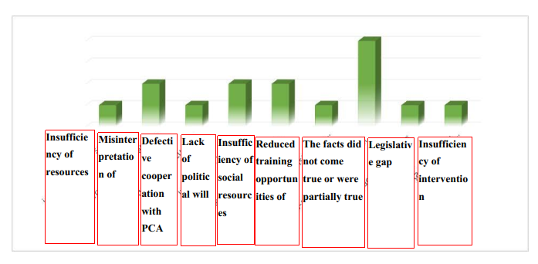

Source: Opinions with recommendations of the Children's Ombudsman during 2016 - first half of 2020 provided by the PAO

We reiterate that the Ombudsman institution is an institution of law whose value is manifested in the prevention of illegalities. This presupposes both the analysis of draft legislation proposed for public consultation and the submission of proposals to amend legislation, referrals to the Constitutional Court, as well as analysing information on allegations of violations of children's rights. These allegations include both definite information on the act committed by natural or legal persons, regardless of the form of ownership, concerning the child, and information on the possibility of committing the illegality. The Children's Ombudsman has already decided in his or her own mind whether to examine the matter raised. There are situations where the intervention of the Children's Ombudsman must be operational (e.g. in cases of domestic violence), when the child's life or health may be in imminent danger. The fact that the authorities, whose intervention has been requested, have stated that the facts alleged have not been proven, essentially gives the Ombudsman the assurance that the child is out of danger. For these reasons, one of the indicators of non- or partial fulfilment was identified as the non-assertion of facts.

From another point of view this indicator also warns against:

* the need to develop the professionalism of public authorities when examining/investigating cases involving children, but also
* the need for further investigation by the PAO before issuing the feedback.

In addition to opinions with recommendations, the Children's Ombudsman drafts and submits to the public (public authorities, media, etc.) thematic reports, annual reports, in which recommendations are also submitted to the authorities with a view to improving the legal system in various areas of children's rights.

In addition to the recommendations in the opinions, pursuant to art. 22 (2) and art. 29 of the Law on the People's Advocate (Ombudsman), the People's Advocate for Children's Rights drafts and submits thematic reports, special reports or annual reports through which the public authorities are made aware of the problems identified and the relevant recommendations.[9] The Law on the People's Advocate (Ombudsman) does not provide for a concrete mechanism to monitor the implementation of the recommendations in the reports. This allows the PAO to independently establish a form of monitoring the level of implementation of the Ombudsman's recommendations.

1. **THE LEGAL MECHANISMS FOR MONITORING THE IMPLEMENTATION WAY OF RECOMMENDATIONS WITHIN THE PEOPLE' S ADVOCATE OFFICE**

According to art.1 (2) of the Law on the People's Advocate (Ombudsman), the concept of monitoring is broadly defined as one of the forms of human rights protection at national level.

Broadly speaking, monitoring means supervising and assessing the level of implementation of the recommendations of the People’s Advocate for Children’s Rights by public authorities.

In general, the basic objectives of monitoring the recommendations of the PACR are:

* To identify the degree of implementation of the recommendations;
* To ascertain whether the implementation way has achieved the basic purpose of the recommendation;
* To identify the causes blocking the possibility of implementing the recommendations and to identify new solutions.

These aspects allow:

* the objective assessment of the level of implementation of the recommendations,
* the identification of barriers that hinder their implementation, and respectively,
* the identification of a new ways of intervention.

The international standards[10] allow the Ombudsman Institution to use a range of legal instruments in the process of monitoring both the implementation way of recommendations and the enforcement of human rights. Already each country establishes a mechanism that the human rights institution will use in the process of monitoring the implementation way of the Ombudsman's recommendations.

The concerned mechanism is intended to hold public authorities accountable, but also to establish an internal algorithm for monitoring the implementation of the Ombudsman's feedback.

According to a report by the Organization for Economic Cooperation and Development[11] concerning the work of Ombudsmen, the culture of open government refers to the application of the principles of transparency, integrity, accountability and participation. In the light of this report, the levers used by mediators to present their recommendations are: regular reports; publication on the website; special reports, media; intervention in parliamentary sessions and press conferences.

The Belgrade Principles[12] recommend that the human rights institution should work in close cooperation with the Parliament to monitor the implementation way of the Ombudsman's recommendations and to identify optimal solutions.

In this context, according to art.11 (c) of the Law no.52 of 03.04.2014 on the People's Advocate (Ombudsman): "In exercising his/her mandate, the People's Advocate has the right... to attend and speak at the meetings of the Parliament, of the Government...".

In the Parliament's Rules[13] and in the Government's Rules[14], however, there is no provision regulating the intervention way of the People’s Advocate/ People's Advocate for Children's Rights in parliamentary meetings or Government meetings. I would like to remind you that, according to the Law on the People’s Advocate (Ombudsman), the PA/PACR has the right to attend any meeting of the Government or Parliament whenever it deems necessary in order to protect the fundamental rights and freedoms of the human being/child.

This gap obstructs the implementation of art.11 (c) of the Law on the People's Advocate (Ombudsman) which precludes the exercise of the mandate of the Children's Ombudsman according to international standards.

The Figure no.4 shows the level of implementation of opinions with recommendations during 2016-2020. The existence of a significant number of opinions during the period in question to which no response was provided reveals that the internal mechanism for monitoring the implementation way of the recommendations of the Children's Ombudsman is uncertain one.

**Figure No. 4**

Level of opinions implementation 2016-2020

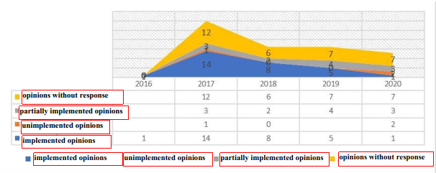

Source: Opinions with recommendations of the Children's Ombudsman during 2016 - first half of 2020 provided by PAO

The Law on the People's Advocate establishes a general mechanism for monitoring the implementation of recommendations in opinions through art.24, which expressly provides that:

“(3) The authority or responsible official who did receive the notice is obliged to review it in a 30 day term and to communicate in writing to the People’s Advocate on the measures undertaken in order to remedy the situation.

(4) In the case when the People’s Advocate disagrees with the undertaken measures, he/she has the right to address to a hierarchically superior body to undertake measures necessary to enforce the recommendations covered by his/her notice and/or inform the public opinion. The hierarchically superior body is obliged to communicate on the measures undertaken in a 45 day term.”

It should be noted that an effective monitoring of the level of implementation of the PACR recommendations is conditional by an internal procedure, within the PAO, for keeping records of the feedback. For these reasons, it is important for the PAO to have a well-developed management of documents, with disaggregated data, based on the specific activity and acts issued by the Ombudsmen, which allows for the rapid identification of unsolved cases or those without an answer from the authorities.

I would point out that, in addition to opinions, the People's Advocate for Children’s Rights also submits recommendations to the public authorities through her reports (thematic, special, annual), but a concrete mechanism for interacting in such situations with the authorities concerned is not regulated, which creates uncertainty for the Ombudsman institution, because there is no concrete procedure that it should follow, and for the public authorities, because they do not know how they should react, especially in cases where recommendations can be implemented over a longer period of time, or cannot be implemented for socio-economic reasons.

In this context, there is a need to establish constructive communication with public authorities in order to identify ways of implementing the recommendations and ensuring the observance of children's rights.

The survey conducted with public authorities confirms that a constructive dialogue of the PACR with public authorities would be one of the most effective ways to identify legal ways to solve problems detected in the field of children's rights. Thus, out of the total number of respondents, 56% mentioned that not all the Ombudsman's recommendations were possible to implement, as shown in Figure no. 5.

**Figure no. 5**

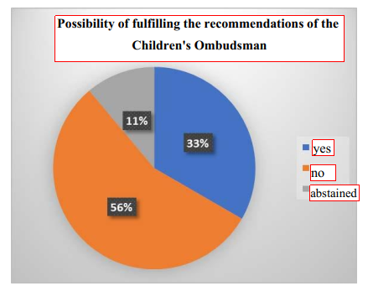

Source: Public authorities’ answers to the survey

Among the basic impediments to the implementation of the recommendations of the PACR, in the opinion of the authorities surveyed, the following were invoked: lack of financial means, difficult cooperation with other public authorities responsible for children's issues, insufficient time set aside in the Ombudsman's opinions, sometimes lack of political will and the existence of legislative gaps. All these issues are reflected more in detail in Figure no. 6.

**Figure no. 6**

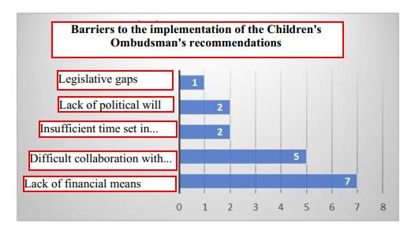

Source: Public authorities’ answers to the survey

In addition to the factors mentioned, some of the authorities surveyed reported that the overly general wording of the recommendations do not allow them to identify immediate solutions to the problems identified.

This makes it necessary to reassess the tactics of formulating recommendations in order to avoid confusion and to provide real support to the relevant authorities in the process of ensuring observance of children's rights. Also, during the analysis of the PACR opinions from 2016-2020, it was observed that for the last 2 years the opinions do not have a unique form and structure of presentation of the problem, practice and international standards, which needs to be remedied.

**Figure no. 7**

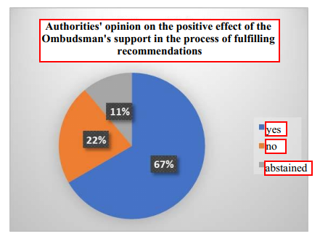

Source: Public authorities’ answers to the survey

Another aspect analysed in the survey was the opinion of the authorities regarding the need for the intervention of the PACR in the process of making recommendations. 67% of the respondents said that the support of the Ombudsman would have a positive effect on the process of ensuring observance of children's rights. The mechanism of intervention being mentioned by organizing or participating in various working groups, meetings and organization of trainings.

In essence, the survey carried out with public authorities showed that their dialogue with the PACR is important and necessary both at the stage of preventing and combating illegalities and at the stage of making recommendations. As society evolves, the problems faced by children, their status in cases examined by the authorities and the difficulties faced by public authorities in ensuring observance of children's rights evolve. The social realities impose the need to find new solutions to existing problems in this field and the role of the PACR in this respect is a crucial one.

The analysis of the opinions with recommendations and the opinions of the authorities show that psychological and pedagogical assistance are key aspects for rehabilitation, resocialization and social inclusion of children at risk or in difficulty, regardless of their status at the time. And these services can only be provided through the creation of a dialogue and constructive cooperation between public authorities, civil society and the institution of PACR.

1. **THE INTERNATIONAL PRACTICE ON THE IMPLEMENTATION OF THE OMBUDSMAN'S RECOMMENDATIONS**

The international standards set guidelines for the Ombudsman's activity. Although each country has its own domestic legislation and its own model of intervention and interaction with public authorities, there are certain general principles that the Ombudsman institution is entitled to observe.

According to p. 17 of the Principles for the Protection and Promotion of the Ombudsman Institution (The Venice Principles): "The Ombudsman shall have the power to address individual recommendations to any bodies or institutions within the competence of the Institution. The Ombudsman shall have the legally enforceable right to demand that officials and authorities respond within a reasonable time set by the Ombudsman".

According to the standards of practice established by the International Ombudsman Association[15], the Ombudsman does not make binding decisions, does not impose guidance and does not provide rule on the problems of organizations.

Moreover, according to the same standards, the Ombudsman identifies trends, issues and concerns regarding policies and procedures that cover future problems and potential concerns, without threatening confidentiality or anonymity, and provides recommendations to address them appropriately. In Italy[16], for example, currently the opinions and recommendations expressed by the Ombudsman institution are not binding, but are intended to guide the actions of institutions at legislative and governmental level. In fact, the Ombudsman's recommendations have been taken into account by the institutions in several cases, for example: his recommendations have stimulated the approval of laws - such as the law that established a specific provision aimed at "care leavers" - or parliamentary motions. In addition, documents such as the "Charter of Children's Rights in the context of the separation of their parents" have begun to be taken into account in the provisions of the Judicial Authorities.

One of the mechanisms used by the Ontario Ombudsman's Office[17] is post-investigation monitoring, which is considered part of the investigation. This stage involves:

* to include recommendations in each report to the authorities with a request for a written response;
* the analysis of the report concerned and publication of the progress made by the responsible authorities in implementing the Ombudsman's recommendations;
* the involvement of the media as a guarantor of monitoring;
* the monitoring relevant information from other sources.

One of the forms of monitoring is the analysis of the legal framework and the submission of proposals to amend the legislation. In Sweden, for example, the Ombudsman is empowered to submit proposals to amend legislation if legislative gaps are identified. Also in Estonia and Iceland the Ombudsman is empowered to come forward with proposals to amend legislation.[18]

The Member States must impose an obligation on all addressees of the Ombudsman Institution recommendations to provide a reasoned reply within a reasonable time. Thus, in Ireland, Croatia the Ombudsman independently determines the time limit for the examination of the recommendation by the public authorities.[19] In the Republic of SRPSKA (one of the entities of Bosnia and Herzegovina) the time limit for the examination of the Ombudsman's recommendation is 15 days and in Poland 30 days.[20]

It is certain that the Ombudsman's feedbacks are not always fully implemented as recommendations. For example, according to the report presented by the Ombudsman of Manitoba during 2008-2012, 53% of the recommendations in the special reports have been implemented, 29% are in the process of implementation, 5% are without an answer.[21] In Croatia, the percentage of acceptance and implementation of the Ombudsman's recommendations is on average 20-30%, as many recommendations are accepted and taken up in principle, but their implementation depends on the individual financial capacities of the departments/authorities.[22]

One of the existing sources reveals that: "In most legal systems, it is stipulated that recommendations can be addressed directly to the administrative unit under control; exceptions are found in Germany and Austria, where they must be addressed to the highest possible body. In some cases, it is stipulated that recommendations may be addressed, as a rule, to the higher hierarchical body and not to the institution under review; an example is the Hungarian Ombudsman, who may address either the institution under review or the higher hierarchical body. The legal situation in the UK is unique because of indirect access to the Ombudsman. A special regulation is found in Luxembourg, where, if the Ombudsman considers a complaint, he/she can, after hearing the complainant and the administrative institution, issue recommendations to both parties, which could lead to an amicable settlement (*reglement a l'amiable*) or to the improvement of the institution's services.

As regards the answer to recommendations made to administrative bodies, this is regulated differently, with some countries (Bulgaria, Finland, Norway, Denmark, UK, etc.) not providing for a answer to these recommendations. However, the practice shows that the Danish Ombudsman, in proportion to his/her powers, is entitled to request written comments from administrative bodies, within the limits of their responsibility, which is a form of reaction to his/her recommendations. The Finnish Ombudsman also stipulates that the administrative body under review must announce the action taken on his recommendation. In the same vein, the Norwegian Ombudsman indicates that the administrative bodies to which recommendations are addressed are not obliged to implement them, but must in any case provide some reaction to the recommendations. For the other states, different nuances of reaction are observed; thus, for most of them, the way of reaction is not clearly described, but only a response is required which must be formulated within a certain period of time.

This duration is determined either by the ombudsman, at his or her discretion (as in Estonia, France, Greece), or is stipulated by law."[23]

An interesting practice is found in the Netherlands, where the Ombudsman does not set a time limits for the consideration of his/her recommendations, but makes a point of mentioning the authority that has successfully implemented the recommendations concerned.[24]

The practice shows that the level of implementation of the Ombudsman's recommendations depends on the legal culture of society, i.e. the level of awareness of the phenomenon of fundamental human/child rights and freedoms, starting with the ordinary citizen and ending with public authorities at all levels. For these reasons, the role of the Ombudsman is an important one in the process of informing the public, through all the channels offered by national legislation, of issues relating to fundamental rights and freedoms.

In this context, I reiterate the importance of establishing a constructive dialogue between the Ombudsman and the public authorities and civil society. This dialogue is the main source of information, but also of identification of possible ways to redress the situation in terms of human rights/child rights, as well as to prevent possible abuses and violations in the issues concerned.

**CONCLUSIONS/RECOMMENDATIONS**

During the report, the problematic aspects of the monitoring process of the implementation of the recommendations of the Children's Ombudsman were presented in the light of international standards, making a parallel with the current de facto situation in this chapter.

The statistical data on the implementation of the opinions of the PACR during 2016-2020 demonstrate the existence of an uncertain mechanism for monitoring the level of implementation of the recommendations. This leads to confusion in the dialogue between the Children's Ombudsman and public authorities, which may lead to poor communication between these institutions.

I would like to mention that a mechanism for monitoring the implementation of recommendations, in order to be functional, needs to be regulated and established the procedure and the way of interaction between authorities in various situations, including those when not all the Ombudsman's recommendations can be implemented immediately.

In order to improve the process of monitoring and implementing the recommendations of the People’s Advocate for Children’s Rights, I submit the following recommendations:

1. Completion of art.29 of the Law no.52/2014 on the People's Advocate (Ombudsman) with a new paragraph, which regulates at least the deadline for considering the recommendations in the thematic reports and special reports and providing a response to the Children's Ombudsman.
2. Establishing an internal mechanism for monitoring the level of implementation of the recommendations of the Children's Ombudsman by:

* Developing the electronic document management system within the institution in order to keep a record of all opinions and reports with recommendations addressed to the public authorities, highlighting those to which the Ombudsman has not received a response or one of impossibility of implementation;
* Drawing up an internal procedure for monitoring and intervening in the process of implementing the Ombudsman's recommendations. As a reference in this respect, I present the matrix in Annexes no. 4 and no. 5.

1. Establishing, in agreement with the Parliament, a practice of systematic meetings in order to discuss the most pressing problems detected in the field of children's rights, reflected both in opinions and reports, as well as the impediments faced by public authorities in implementing the recommendations of the People’s Advocate for Children’s Rights.
2. In the light of the Belgrade Principles to submit proposals to amend/complete the Rules of Parliament and the Rules of Government in order to create the necessary conditions for the de facto implementation of art. 11 (c) of the Law no. 52/2014 on the People’s Advocate (Ombudsman).
3. In order to improve the quality of the opinions with recommendations it would be appropriate to:

* to establish a single format, according to structure and form, of the opinions;
* to avoid recommendations that are too general;
* to specify which public authorities are to implement the recommendation.

1. Establishing a constructive dialogue with central and local public authorities by:

* Providing informational assistance to prevent the risk of violation of child's rights;
* Providing regular training to public authorities, based on their needs;
* Identifying the barriers faced by CPA and LPA in the process of ensuring observance for children's rights, with a view to establishing an effective formula for working together; and
* Through various meetings/sessions to facilitate dialogue between public authorities and civil society in order to identify optimal solutions concerning the children;

**ANNEXES**

**ANNEX I**

**LEGAL FRAMEWORK**

* Universal Declaration of Human Rights, adopted by the United Nations General Assembly on September 10, 1948;
* Convention for the Protection of Human Rights and Fundamental Freedoms, adopted at Rome on November 4, 1950, entered into force on September 3, 1953;
* UN Convention on the Rights of the Child, ratified by the Republic of Moldova on 25.02.1993;
* Principles relating to the status of national institutions for the promotion and protection of human rights (The Paris Principles), adopted by United Nations (UN) General Assembly Resolution No. 48/134 of December 20, 1993;
* Principles on the Protection and Promotion of the Ombudsman Institution (The Venice Principles), adopted by the Venice Commission at its 118th Plenary Session (March 15-16, 2019);
* Belgrade Principles on Interaction between National Human Rights Institutions and Parliaments, UN (Belgrade, Serbia, February 22-23, 2012) *;
* Law no. 52 of 03.04.2014 on the People's Advocate (Ombudsman);
* Law no. 797 of 02.04.1996 for the adoption of the Parliament Rules;
* Government Decision no. 610 of 03.07.2018 for the approval of the Government Regulation

**ANNEX No.2**

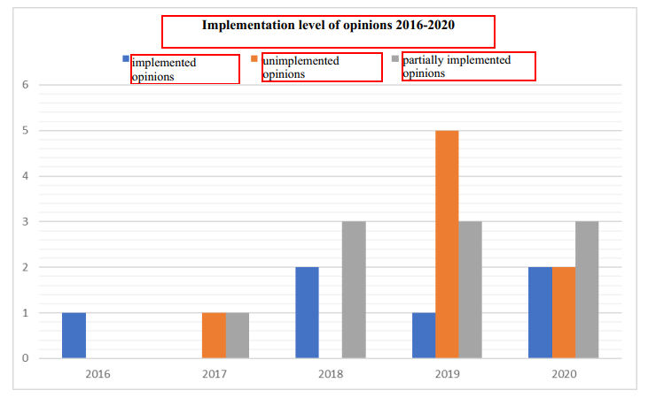

Source: Opinions of the Children's Ombudsman in the period 2016 - first half of 2020 provided by the PAO

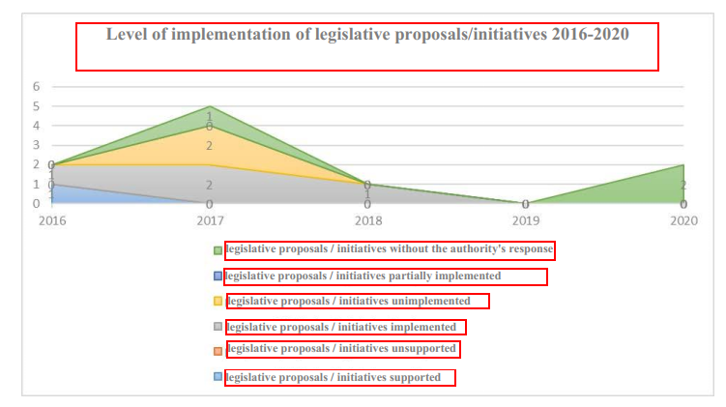

Source: Proposals / legislative initiatives of the Children's Ombudsman during 2016- first half of 2020 offered by the PAO

**ANNEX No.3**

**The Children Ombudsman's reports for 2016-2020:**

1. Thematic report “Assessment of the efficiency and effectiveness of inter-sectoral cooperation mechanisms in the field of child rights protection” Experts: Mariana Ianachevici, Child Protection Consultant; Tatiana Danilescu, Lawyer, Child Protection Consultant. CHISINAU, 2020 (with the financial support of UNICEF);
2. Report “Assessment of the observance of the children's rights in detention in connection with the criminal investigation or execution of the sentence”, CHISINAU, 2020;
3. Report on the observance of children's rights in the Republic of Moldova in 2019, Chisinau 2020 (with the financial support of UNICEF);
4. Activity report green line of the Children's Ombudsman, 2019;
5. Report on the observance of children's rights in the Republic of Moldova in 2018, Chisinau 2019;
6. Assessment of the observance of the children's rights in state custody in connection with the criminal investigation or execution of the sentence, Chisinau 2019
7. Study “Assessment of the need to adjust the regulatory framework of mechanisms to ensure the protection of children in risk situations to the international standards in order to ensure proper monitoring of the UN Convention on the Rights of the Child” (with financial support from UNICEF);
8. Report on the observance of children's rights in the Republic of Moldova in 2017, Chisinau 2018 (with the financial support of UNICEF);
9. Thematic report “Observance of the children's rights aged 0-3 years who are with their mothers serving their sentences in penitentiary institutions in the Republic of Moldova”, Chisinau 2018;
10. Report on the observance of children's rights in the Republic of Moldova in 2017, Chisinau 2018;
11. Report on the observance of children's rights in the Republic of Moldova in 2016, Chisinau 2017 (with the financial support of UNICEF);
12. Thematic study on the observance of children's rights to names and citizenship, Chisinau 2017 (with the financial support of UNICEF);
13. Special report “Assessment of the situation of children placed in Boarding houses for children with mental deficiencies of Orhei and Hincesti in the process of deinstitutionalization”, Chisinau 2017, (with the financial support of UNICEF);
14. Report on the social inclusion of children with sensory disabilities, Chisinau 2017 (with financial support from UNICEF);
15. Alternative report of the People's Advocate Office to the Committee on the Rights of the Child;
16. Thematic report on the social inclusion of children with autism spectrum disorders in the Republic of Moldova, Chisinau 2016, (with the financial support of UNICEF);
17. Thematic report analysis of the activity of the guardianship authorities - the territorial structure of social assistance and family protection, as a result of the examination of the models of drawn up documents, Chisinau 2016;
18. Monitoring the observance of children's rights in the process of providing pre-hospital emergency medical care, Chisinau 2016.

Source: <http://ombudsman.md/avocatul-copilului/rapoarte/>

**ANNEX No.4**

**Monitoring the implementation way**

**of the Children Ombudsman’s recommendations**

By requesting information from the authorities

Checking the information

On-site visit

Discussions with people whose rights have been violated

Monitoring the assurance of fundamental rights and freedoms

Request from the relevant authority to periodically report about the existing situation regarding the approached problem

**ANNEX No.5**

**Implementation of recommendations from opinions / reports**

PACR recommendations

Simple

With a proposal to amend the institutional legislation

Accepted

Partially accepted

Not accepted

If the Government does not come up with the legislative initiative, the PACR submits a proposal to amend the legislation

Address to the hierarchically superior institution

Implemented

Implemented

Where appropriate the organization:

- the round table;

- the working meeting:

- coverage of information in the media

Request the opinion with solutions on the problem from the public authorities

Where appropriate, request the opinion of international human rights institutions

- Request of the hierarchically superior authority to restore rights

- court action

yes

no

1. https://booknation.ro/citate-despre-copii/;
2. Art. 2 of the UN Convention on the Rights of the Child;
3. Art. 6 (2) of the UN Convention on Rights of the Child;
4. Art. 3 (1) of the UN Convention on the Rights of the Child: “In all actions concerning children, undertaken by public or private social assistance institutions, courts, administrative authorities or legislative bodies, the interests of the child will prevail. ”;
5. Art.12 of the UN Convention on the Rights of the Child;
6. Report no. 387 of 25-07-2008 on the observance of human rights in the Republic of Moldova in 2007, Published: 25.07.2008 in the Official Gazette no. 134-137 art. 387, in the Chapter “Children and Youth”;
7. Law no. 52/2014 on the People's Advocate (Ombudsman);
8. Art.1 (2) of Law no. 52/2014 on the People's Advocate (Ombudsman);
9. The reports of the People's Advocate for Children's Rights during 2016-2020 are presented in annex no.3;
10. Principles on the Status of National Institutions for the Promotion and Protection of Human Rights (The Paris Principles), adopted by United Nations General Assembly (UN) Resolution no. 48/134 of December 20, 1993, the Principles on the Protection and Promotion of the Institution of the Ombudsman (the Venice Principles), adopted by the Venice Commission at its 118th Plenary Session (March 15-16 2019; Belgrade National Human Rights Institutions and Parliaments, UN (Belgrade, Serbia, February 22-23, 2012) *;
11. The role of mediators in open governance, OCDE Working Paper on Public Governance No. 29; OCDE Edition 2018, p.15;
12. Belgrade National Human Rights Institutions and Parliaments, UN (Belgrade, Serbia, February 22-23, 2012)*;
13. Law no. 797-XIII of 02.04.1996 for the adoption of the Parliament Rule *;
14. Government Regulation, approved by Government Decision no. 610 of July 3, 2018;
15. <https://www.ombudsassociation.org/assets/docs/SOP-French.pdf>, point 4.3 of the Practical Standards;
16. Answer of the ENOC states regarding the implementation of the recommendations of the Children's Ombudsman;
17. “Ombudsman Strategies for Getting to Yes and Beyond: Acceptance and Implementation of Recommendations” Paul Dubé Ombudsman of Ontario April 2017, p.10;
18. Recueil de bonnes pratiques.pdf.pdf, pag.6;
19. Recueil de bonnes pratiques.pdf.pdf, pct.9, pag.8;
20. Answer of the ENOC states regarding the implementation of the recommendations of the Children's Ombudsman;
21. <https://www.gov.mb.ca/fs/changesforchildren/pubs/2012_ombudsman_AR.pdf>;
22. Answer of the ENOC states regarding the implementation of the recommendations of the Children's Ombudsman;
23. INSTITUTION OF THE OMBUDSMAN AT EUROPEAN LEVEL, Institution of the Ombudsman at European level / Grigore Alexandru Jianu. - Bucharest: I.R.D.O Publishing House, 2013, p. 22;
24. Answer of the ENOC states regarding the implementation of the recommendations of the Children's Ombudsman;